HW1:
What is the output of the following code?
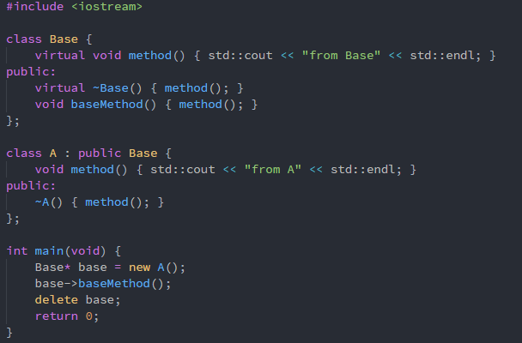
Ans:
from A
from A
from Base
HW2:
What is the output of the program!! And please explain what is going on?
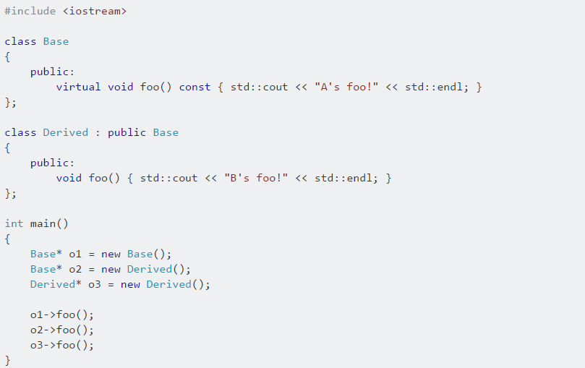
Ans:
A’s foo!
A’s foo! -> Because Base Class is void foo() const and Derived Class is void foo(), they aren’t same signature. As a result, it will not be override.
B’s foo!
HW3:
請以多型完成下列程式碼，演奏弦樂四重奏。
public class V {
public static void main(String[] args) {
// 弦樂四重奏
Instrument[] stringQuartet = { new Violin(), new Violin(), new Viola(), new Cello() };
// play the music for me
// implement HERE !!!
For(Instrument instrument : stringQuartet){
instrument.play();
}
}
}

abstract class Instrument {
abstract public void play();
}

// 小提琴
class Violin extends Instrument {
@Override
public void play() {
System.out.println("旋律");
}
}

// 中提琴
class Viola extends Instrument {
@Override
public void play() {
System.out.println("合旋");

}
}

// 大提琴
class Cello extends Instrument {
@Override
public void play() {
System.out.println("低音");

}
}

HW4:
Please implement (use polymorphism) the following code to make result generate the same output.
#include <iostream>
#include <vector>

using namespace std;

class Base {
public:
virtual void print() { cout << "Base" << endl; }
virtual ~Base() {}
};
class A : public Base{
public:
void print() { cout << "A" << endl; }
}
class B : public Base{
public:
void print() { cout << "B" << endl; }
}
int main(void) {
vector<Base*> bases = { new Base(), new A(), new B() };
for (Base* b : bases) {
b->print();
}

for (Base* b : bases) {
delete b;
b = nullptr;
}
bases.clear();
}

Please make inherit fit following class diagram.
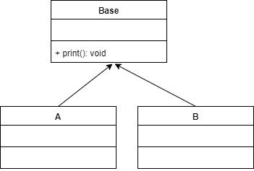
Output:
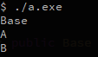

HW5:
Modify the attachment by using polymorphism.
#include <stdio.h>
#include <assert.h>

#define SIZE 3

typedef enum {
Comic,
Novel,
Magazine
} book_type;

typedef struct Book {
book_type type;
} Book;

void print_book_type(Book*);

int main(void) {
Book books[SIZE];
books[0].type = Comic;
books[1].type = Novel;
books[2].type = Magazine;

for (int i = 0; i < SIZE; i++) {
print_book_type(&books[i]);
}

return 0;
}

void print_book_type(Book* book) {
assert(book);

switch (book->type) {
case Comic:
printf("Comic\n");
break;
case Novel:
printf("Novel\n");
break;
case Magazine:
printf("Maganize\n");
break;
}
}

Ans:
#include <stdio.h>
#include <assert.h>
#define SIZE 3
typedef struct Book book;
struct book{
void (*print_type)(Book*);
}
void print_comic(Book* book){
printf(“Comic\n”);
}
void print_novel(Book* book){
printf(“Novel\n”);
}
void print_magazine(Book* book){
printf(“Magazine\n”);
}
void print_book_type(Book* book){
assert(book);
book -> print_type(book);
}
int main(void){
Book books[SIZE];
books[0].print_type = print_comic;
books[1].print_type = print_novel;
books[2].print_type = print_magazine;
for(int i = 0; i < SIZE; i++){
print_book_type(&books[i]);
}
return 0;}

HW6:
Please write a main function (with polymorphism way) to make result generate the same output.
#include <iostream>
using namespace std;

class Animal {
public:
virtual void speak() = 0;
virtual ~Animal() {}
};
class Cat : public Animal {
public:
void speak() {
cout << "meow" << endl;
}
};
class Cow : public Animal {
public:
void speak() {
cout << "moo" << endl;
}
};
int main(){
Animal* animals[] = {new Cat(), new Cow()};
for(Animal* animal : animals){
animal->speak();
}
for(Animal* animal : animals){
delete animal;
}
return 0;
}
Output:


